Narrative Tenses
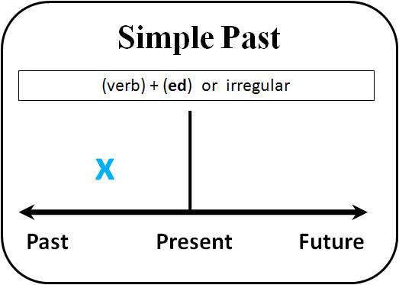
Use the past simple for completed actions in hte past which tell the main event in a story.
I picked up the phone and ordered a pizza.
When I saw the boy coming towards me, I said hello.
She took a deep breath, tried to calm down and then spoke.
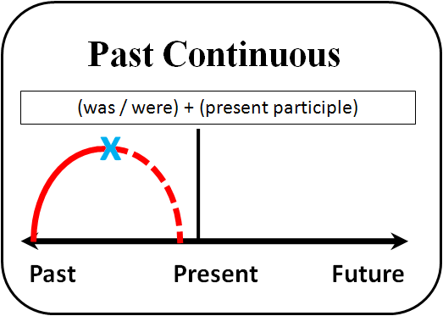
Use the past continuous
a) to set the general scene of a story
The music was playing softly, and the guests were arriving one by one.
The wind was blowing gently and the birds were singing the best songs ever.
He was moving very fast, looking around and giving orders to the other police officers around.
b) to talk about actions in progress at or around a particular poing in a story, often interrupted by another (shorter) action or event (usually in the past simple).
He was talking loudly when the waiter brought his food.
Everybody was working in the office when the electricity went off.
She was making jokes and telling anecdotes when the teacher asked her a difficult question.
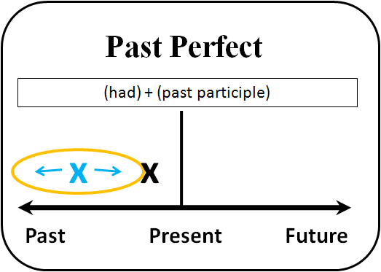
Use the past perfect to talk about actions or situations that were completed before another action in the story. The actions are often mentioned out of time sequence, and the past perfect makes the order clear.
When I got to the restaurant, all my friends had eaten and some of them had left.
Before I called him, I had prepared a farewell speech.
She went to bed and took a good night sleep after she had finished all the housework.
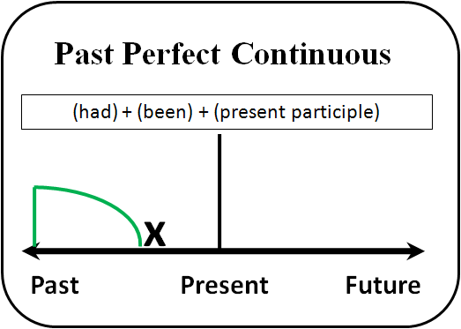
Use the past perfect continuous to talk about longer actions or situations which started before and continued up to a point in the story.
She had been studying for hours when she found out the exam was cancelled.
They had been talking about the details of the party for a couple of hours , so when I asked them whether they wanted a break, they all agreed.

